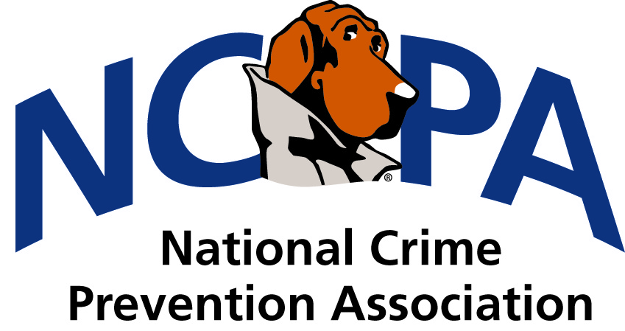
MEMBERSHIP APPLICATION

Prefix First Name MI Last Name Suffix
Title/Positon
Agency/Organization
Work Address Preferred Mailing Address Preferred Billing Address
☐

Street
Address
Mailing Address
(If different)
City | State |  | Zip | Country
Phone |  | Fax
Toll free |  | Website

Home Address Preferred Mailing Address Preferred Billing Address

Street
Address
Mailing Address
(If different)
City | State |  | Zip | Country
Phone |  | Fax

Preferred Email Address _________________________________________________________
Cell Phone Number _____________________________________________________________
Gender (Check One) Male Female
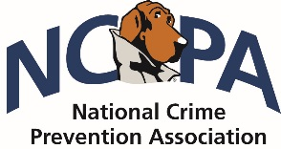
NCPC MEMBERSHIP APPLICATON (continued)

Have you previously been a member of NCPA? Yes No
How did you learn about NCPA?
Internet Mailing Training/Conference
Current NCPA member Former NCPA member Other_________________
Membership Advantages
As a member of the National Crime Prevention Association, you will receive many benefits that include but are not limited to those listed below:
- NCPA member kit with resources CD
- Members Only E-Newsletter
- Training at the regional and national levels
- Ability to network across the country
- Access to crime prevention publications
- Free or discounted crime prevention resources
- Access to online prevention training
- Networking opportunities
- In-service training credit certification for practitioners

Membership Dues
The annual membership fee is $35.
Payment Instructions
Credit Card Check/Money Order (Payable to Crime Prevention Council)
Type of Card: American Express Visa MasterCard
Credit  Card Number | Exp.  Date
Name as it  appears on card | Security  Code*
Signature
*3-digit number found on back of signature panel of the Visa & MasterCard or 4-digit number found on the front of the American Express
RETURN COMPLETED FORM TO FAX NUMBER 202-296-1356
ATTN: MEMBERSHIP
For further information about NCPC and member benefits, please visit ncpc.org/ncpa or call 202-466-6272

